**IOT – REAL –TIME RIVER WATER QUALITY MONITORNG AND**

**CONTROL SYSTEM**

**ASSIGNMENT -2**

**Python programming**

|  |  |
| --- | --- |
| Assignment Date | 27 September 2022 |
| Student Name | S.SANGEETHA |
| Student Roll Number | 912419104026 |
| Maximum Marks | 10 Marks |

# 1. Build a python code , assume u get temperature and humidity values (generated with random function to a variable )and write a condition to continuously detect alarm in case of high temperature

PYTHON CODE

import random

import time

while(True):

temperature=random.randint(0,1024)

humidity=random.randint(0,150)

print(f' Temperature={temperature}')

print(f' Humidity={humidity}')

if temperature>600*:*

print('Temperature is high \n================*===***====**=')

print("alaram is on")

time.sleep(4)

**PROGRAM WINDOW**

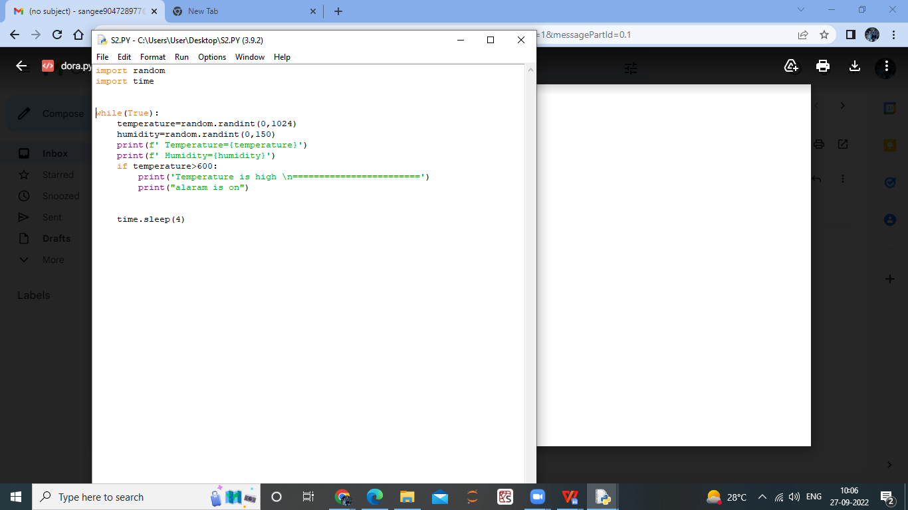

**OUTPUT WINDOW**

